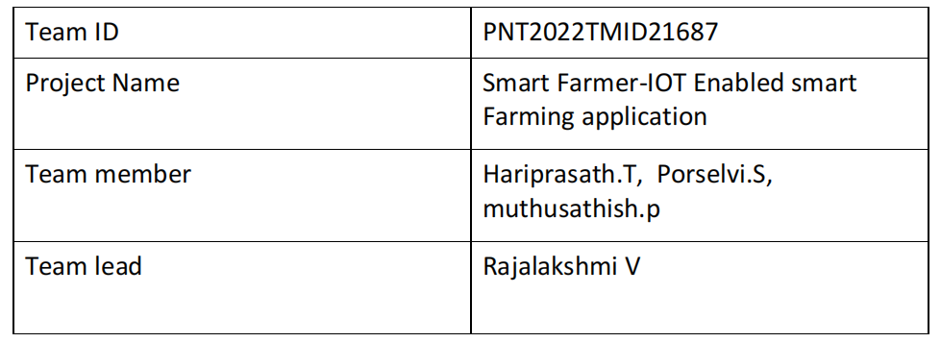

**5.5 Receiving commands from IBM cloud using Python program**  import time import sys

import ibmiotf.application import

ibmiotf.device import

random

#Provide your IBM Watson Device Credentials

organization = "kmp0by" deviceType = "NODEMCU"

deviceId = "12345" authMethod = "use-token-auth"

authToken = "i6X88!f_y3u(DWT7!X"

# # Initialize GPIO

def myCommandCallback(cmd): print("Command received: %s" % cmd.data['command']) status=cmd.data['command'] if status=="motoron": print ("motor is on") elif status == "motoroff": print ("motor is off") else :

print ("please send proper command")

try:

deviceOptions = {"org": organization, "type": deviceType, "id": deviceId,

"auth-method": authMethod, "auth-token": authToken} deviceCli = ibmiotf.device.Client(deviceOptions)

#..............................................

except Exception as e:

print("Caught exception connecting device: %s" % str(e))

sys.exit()

# Connect and send a datapoint "hello" with value "world" into the cloud as an event of type "greeting" 10 times deviceCli.connect()

while True:

#Get Sensor Data from DHT11 temp=random.randint(90,110)

Humid=random.randint(60,100) Mois=random. Randint(20,120) data = { 'temp' : temp, 'Humid': Humid , ‘Mois’: Mois}

#print data def

myOnPublishCallback():

print ("Published Temperature = %s C" % temp, "Humidity = %s %%" % Humid, “Moisture =%s deg c” % Mois “to IBM Watson") success = deviceCli.publishEvent("IoTSensor", "json", data, qos=0,

on_publish=myOnPublishCallback) if not success: print("Not connected to IoTF")

time.sleep(10)

deviceCli.commandCallback = myCommandCallback # Disconnect the device and application from the cloud deviceCli.disconnect()

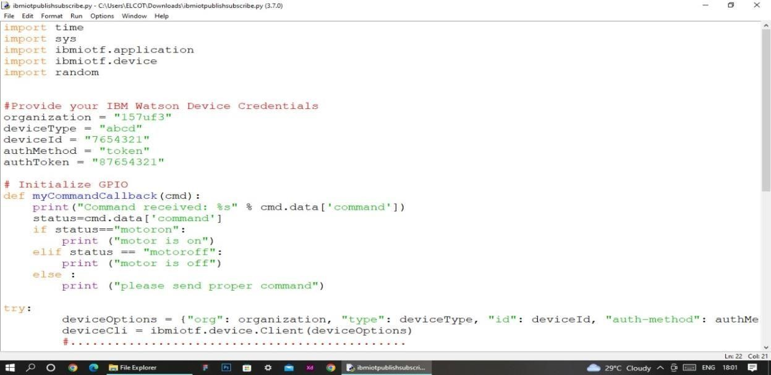

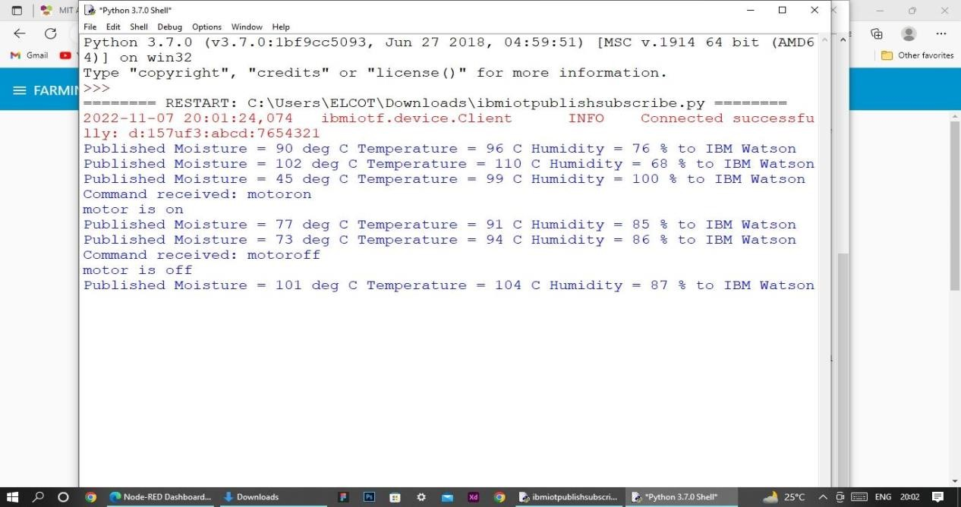

# 6.Flow Chart

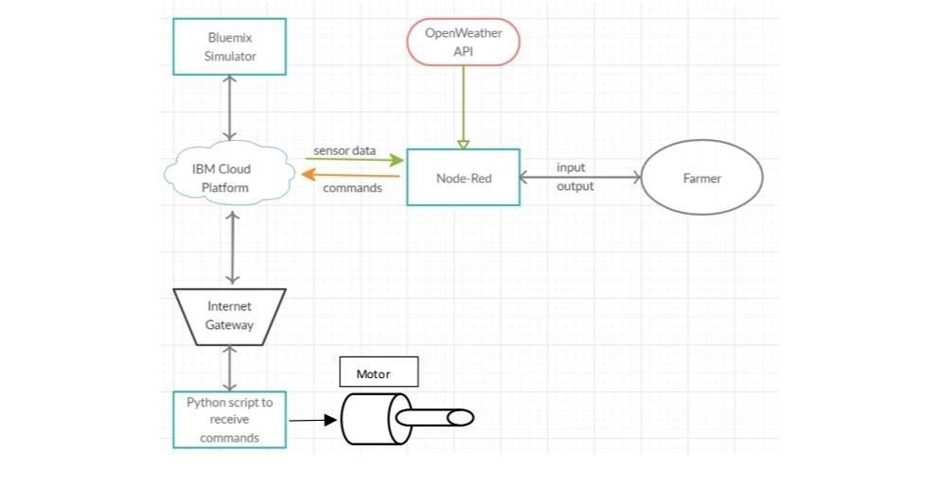

# 7.Observations & Results

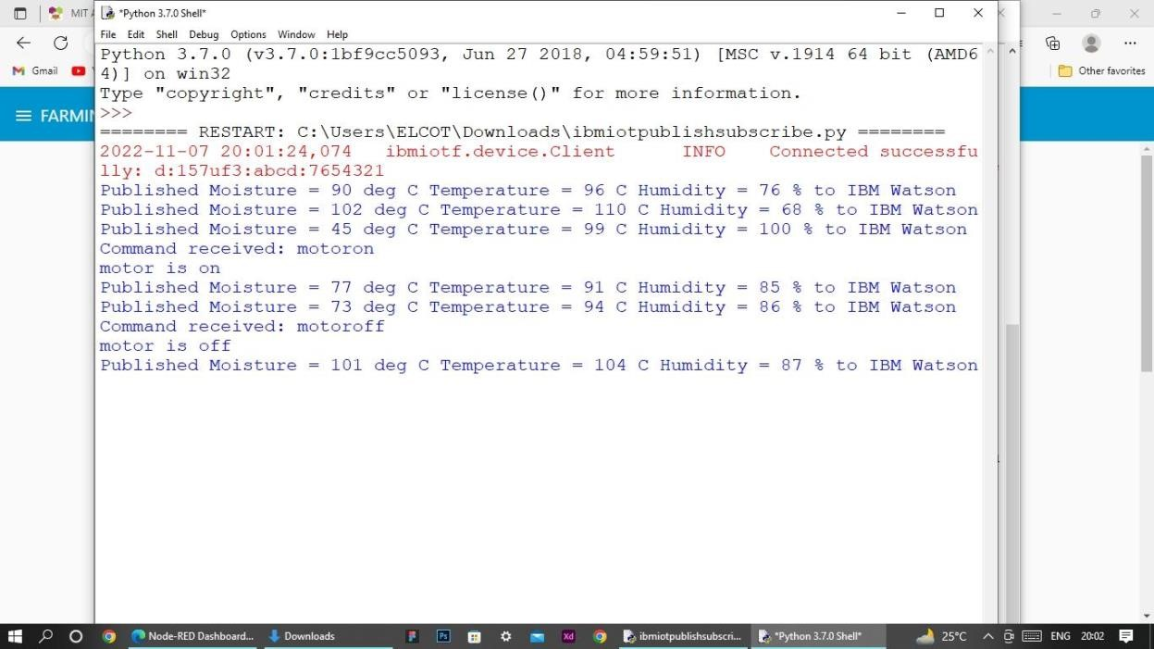

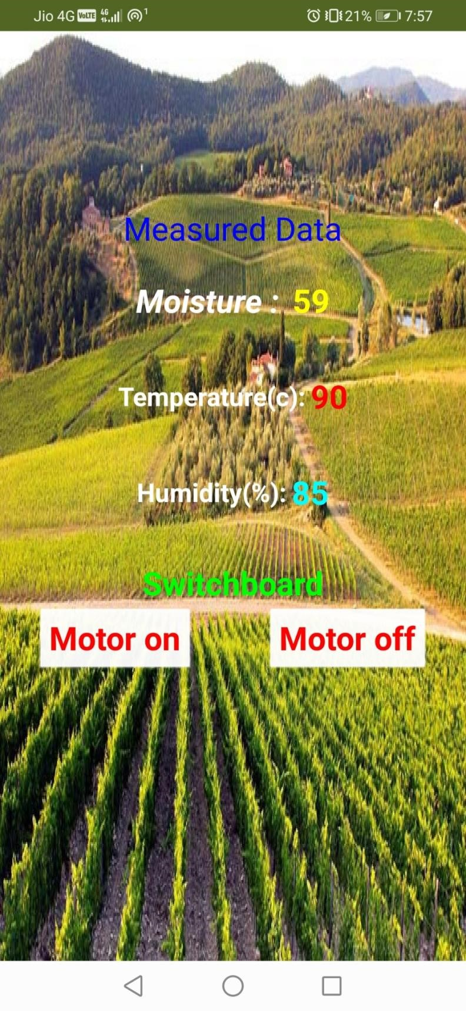

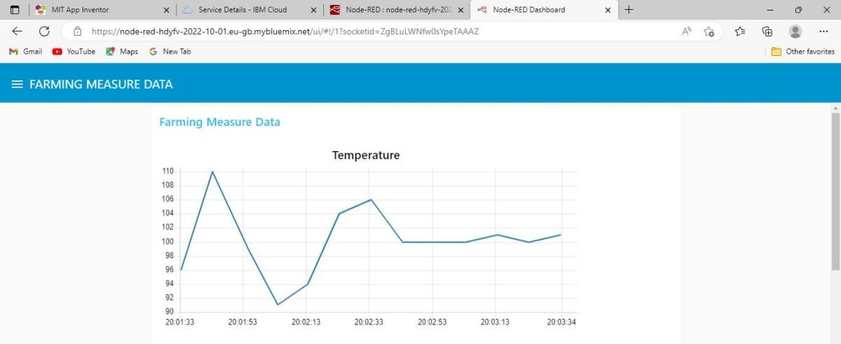



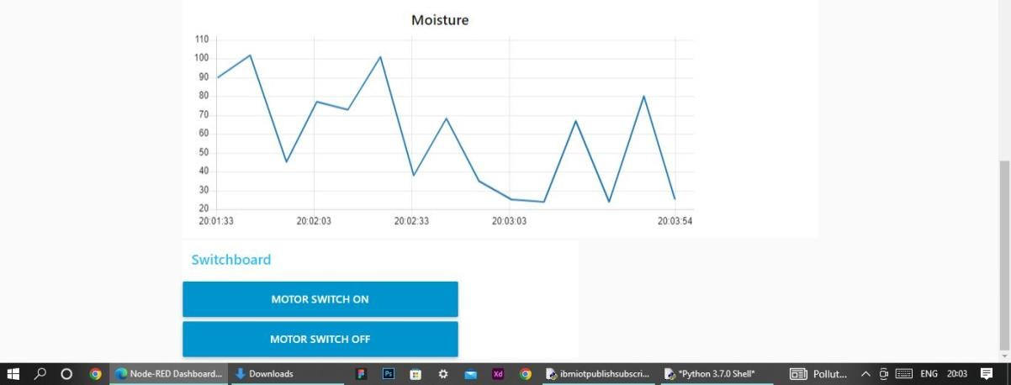

8.Advantages & Disadvantages Advantages:

* Farms can be monitored and controlled remotely.
* Increase in convenience to farmers.
* Less labor cost.
* Better standards of living.

Disadvantages:

* Lack of internet/connectivity issues.
* Added cost of internet and internet gateway infrastructure.
* Farmers wanted to adapt the use of Mobile App.

# 9.Conclusion

Thus the objective of the project to implement an IoT system in order to help farmers to control and monitor their farms has been implemented successfully.

# 10.Bibliography IBM cloud reference: https://cloud.ibm.com/ IoT simulator : https://watson-iot-sensor-simulator.mybluemix.net/ OpenWeather : https://openweathermap.org/